Processing Recycled Spectacles

Lions Clubs throughout the UK collect unwanted and damaged spectacles. These are then sent to Chichester Lions Club which processes tens of thousands of recycled spectacles each year. All donations are examined by a team of Lions and other volunteers in the recycling workshop. Sorted pairs of glasses may then be sent for grading and distribution by Medico France in Le Havre.
Chichester Lions Club sends spectacles directly to contacts running eye clinics in Papua New Guinea, Sri Lanka, Ghana, Nigeria, and Nepal.

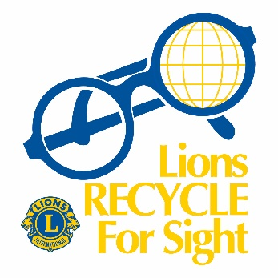

In addition, volunteers from the Unite for Sight charity are supplied with spectacles to take with them on missions to countries across the world.

Scrap metal salvaged from broken and unsuitable spectacles raises funds that support the sorting operation and enable Chichester Lions Club to give financial support to eye-related projects in the UK and overseas.

